EXPERIMENT NO. 10

DESIGN PATTERNS

Aim

Application of at least two types of design patterns in selected case study

Description

OVERVIEW

  - System Overview

The university exam scheduling system takes input from the Professors about their preferences, about course offerings and classrooms from the department secretary, and then proposes a suitable schedule for the courses.

System Context

The system context is defined clearly in the SRS. The department is the main sink of the information. The main sources of information are the Professors (who provide information about their time preferences and maximum enrollment,) and the department secretary (which provides information about courses begin offered, time slots, and available classrooms.)

Stakeholders of PIMS

The main stakeholders and their concerns are:

    - Professors: Their main concern is that their highest priority should be satisfied. This means that the algorithm for scheduling should be such that it can easily be changed with a better algorithm later.

    - Department secretary/Head: The schedule should be fair and should utilize the
resources well. (Again, this means that the scheduling algorithm should be upgradable.)

Scope of this Document

This document describes the proposed architecture for the university exam scheduling system. For architecture, we consider only the component and connector view.

Definitions and Acronyms

As given in the SRS.

ARCHITECTURE DESIGN
As this is a batch processing-type system with inputs coming and output being produced, the most natural style will be the pipe-and-filter style. We use this style for the architecture of the system. The proposed architecture is shown below.

This architecture has three filter components – one to process the information provided in File 1, the other to process the information provided in File 2, and the third to produce the schedule. As the information produced by the first component is also used in the processing of information from File 2 as well as for scheduling, the connections are set accordingly.

In this architecture, we do not require that the components be executed in parallel. For ease of implementation, they may be executed in sequential order, particularly since the file processing modules are not likely to consume much time – the main processing time will be needed by the third component and that remains the same in parallel or serial execution. Any (synchronous or asynchronous) method can be used to support the pipes.

Conclusion

Structural Design
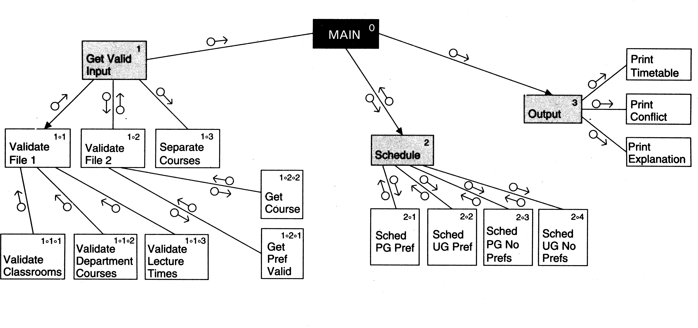

Architecture Diagram
